Computers- I Can

I can…

* Turn on the computer



* Click on the Internet

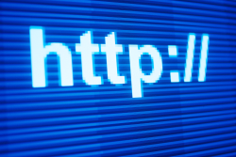

* Click on one of the Bookmarks

C:\Users\ls3rb\AppData\Local\Microsoft\Windows\Temporary Internet Files\Content.IE5\JK51VWQY\MC900013220[1].wmf

* Keep my headphones on

C:\Users\ls3rb\AppData\Local\Microsoft\Windows\Temporary Internet Files\Content.IE5\YN3ZRF8H\MC900297785[1].wmf

* Look at my own computer 