What’s Your Favorite…

- Fill out the survey sheet 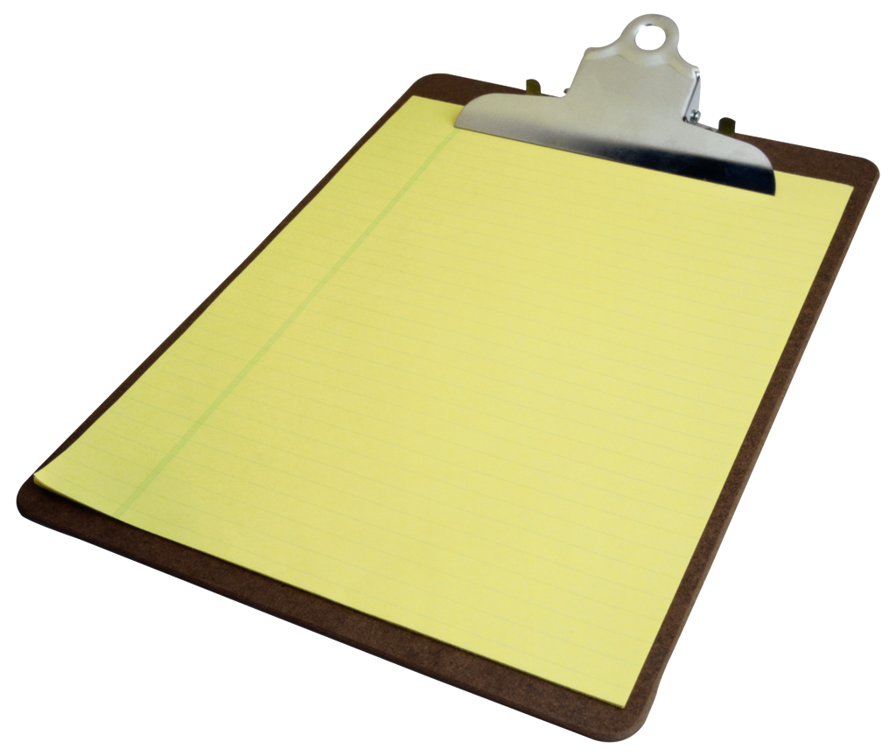
- Fill out the exit slip
- Play FEUD
  - Split the deck in half
  - Each player flips over one card at a time
  - Pick which card is GREATER THAN the other
  - The card that is GREATER THAN wins
  - That player takes both cards
  - Keep playing until someone runs out of cards

