What Do We See In The World Around Us?

At this station you will graph our observations in a picture graph

* Pick one of our observations from morning meeting that you want to graph
* Or, you may choose to graph an observation you have about the classroom
* Graph your data on the graphing sheets

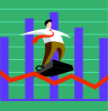

* Do more than one graph if you finish early

